**Program 13:**

1. Write a program to implement the FCFS elevator disk scheduling algorithm. The program should give detail about each disk movement from starting head position (input from the user) and calculate average head movement.
2. Write a program to implement the SSTF elevator disk scheduling algorithm. The program should give detail about each disk movement from starting head position (input from the user) and calculate average head movement.

**Answer:**

1. Source code:

#include <iostream>

#include <vector>

#include <cmath>

using namespace std;

int algo(vector<int> programs,int pos){

cout<<"Disk Movement:-"<<endl;

cout<<"From\tto\tDisk Movement"<<endl;

int sum=0,diff;

for (int i=0; i<(int)programs.size();i++){

diff=abs(pos-programs[i]);

sum+=diff;

cout<<pos<<"\t"<<programs[i]<<"\t"<<diff<<endl;

pos=programs[i];

}

return sum;

}

int main()

{

int n,pos;

cout << "Enter number of programs and Initial position of Head"<<endl;

cin>>n>>pos;

vector<int> programs(n);

cout<<"Enter programs"<<endl;

for (int i=0; i<n;i++){

cin>>programs[i];

}

int total_movements=algo(programs,pos);

total_movements=(float)total_movements;

cout<<"Average disk movement: "<<total_movements/(float)n<<endl;

return 0;

}

Output:

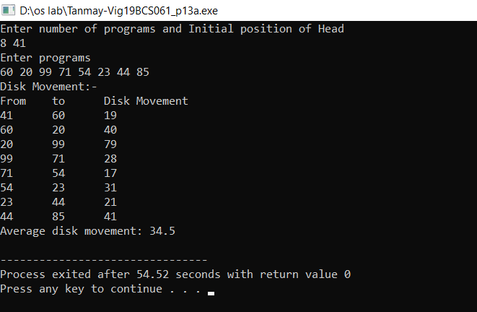

1. Source Code:

#include <iostream>

#include <vector>

#include <cmath>

using namespace std;

int algo(vector<int> programs, int pos){

int total_movement=0, diff,next;

cout<<"Disk Movement:-"<<endl;

cout<<"From\tto\tDisk Movement"<<endl;

while(!programs.empty()){

next=0;

for (int i=0; i!=(int)programs.size(); i++){

if(abs(programs[i]-pos)<abs(programs[next]-pos)){

next=i;

}

}

diff=abs(programs[next]-pos);

total_movement+=diff;

cout<<pos<<"\t"<<programs[next]<<"\t"<<diff<<endl;

pos=programs[next];

programs.erase(programs.begin()+next);

}

return total_movement;

}

int main()

{

int n,pos;

cout << "Enter number of programs and Initial position of Head"<<endl;

cin>>n>>pos;

vector<int> programs(n);

cout<<"Enter programs"<<endl;

for (int i=0; i<n;i++){

cin>>programs[i];

}

int total_movements=algo(programs,pos);

total_movements=(float)total_movements;

cout<<"Average disk movement: "<<total_movements/(float)n<<endl;

return 0;

}

Output:

